What is HRSD in ServiceNow?
HRSD stands for Human Resource Service Delivery. It helps HR teams manage employee requests, like leave, onboarding, or payroll questions, using cases and services.
What is COE in HRSD ServiceNow?
- COE is the Center of Excellence
- HR COE is a data model that helps in organising HR data, services and processes

- Examples of
  - HR Employee Relations
  - HR payrolls
  - HRIT Operations
  - HR Lifecycle events
  - HR talent management
  - HR total rewards
  - HRIT Workforce Administration

How is HRSD different from other ServiceNow modules like ITSM?
These 2 terms are part of 2 different products of SN.

Incident - ITSM - From IT workflow- used by IT user
HR - HRSD - Employee Workflow - Used by employee

Case has different life cycle then Inc and also stored in 2 different tables.

I will not say both are Synonym of each other but yes, looks like similar.

If a employee face, he/ she logged a request which is called case but same user said, his /her laptop not working or net is down, log a Incident.

What are HR Services?
- HR services are the requests and assistance an HR organization provides its employees, such as benefits enrollment, direct deposit setup, and requests for relocation assistance.

hat exactly are HRSD lifecycle events in ServiceNow?
- HRSD lifecycle events are standardized processes built into ServiceNow’s HR Service Delivery module. They automate everyday HR tasks like onboarding new hires, offboarding departing employees, and managing internal transfers.

Describe the role of HR profiles in HRSD.
HR profiles store employee-specific HR info like job, location, or manager—separate from the user table.
What are some key tables in the HRSD module?
Important tables include sn_hr_core_case (HR Case), sn_hr_core_profile (HR Profile), and sn_hr_le_lifecycle_event (Lifecycle Events).
What is the difference between HR Tasks and HR Cases?
HR Case is the main record of a request. HR Tasks are smaller steps within that case, assigned to different agents.
How do you create a new HR service?
Go to HR Services > Create New, fill in the details like name, COE, topic, and workflow, and then publish it.
What is Topic Category?
Topic category is nothing but under which we are going to create HR services
Logic is
COE Topic Category Topics HR Services
These comes under any table of coe.
How do you create a knowledge article for HR services?
Go to Knowledge > Articles, select the HR Knowledge Base, write your article, set the topic and audience, and publish it.
14. What are HR workflows, and how do you customize them?
HR workflows are automated processes that handle steps in an HR case. You can customize them using Flow Designer by adding actions like tasks, emails, or approvals.
15. How do you configure HR Case templates?
Go to HR Case Templates, and define pre-filled values (like category, assignment group, tasks) that auto-populate when a case is created.
What is an HR Catalog Item, and how is it used?
An HR Catalog Item lets users request services via the Employee Center. It’s linked to an HR service and uses record producers to create cases.
. What is an HR Catalog Item, and how is it used?
HR catalog items are the HR services that your organization makes available for employees to request directly from the HR service catalog.
How do you route HR cases to the correct HR agents?
Use Assignment Rules or HR Matching Rules to automatically assign cases based on department, location, or case typ

What are Assignment Rules and Matching Rules in HRSD?
- Assignment Rules: Auto-assign HR cases to groups or users.
- Matching Rules: More advanced—match based on multiple conditions like location, skills, or topic.
How do you restrict access to HR cases?
Use Contextual Security and roles. Only users with roles like sn_hr_core.basic or sn_hr_core.admin can view HR cases based on rules.
What are the use cases of Script Includes in HRSD?
Script Includes are reusable server-side scripts that define functions or classes, facilitating modular and efficient HR service delivery
How do you enable surveys for HR services?
Go to Survey Management, create a survey, link it to the HR service or case closure, and it will trigger after the case is resolved.
How do you customize the HR service portal?
Use Service Portal Configuration to modify themes, widgets, pages, and menus in the Employee Center or HR-specific portal.

user profile vs hr rofile
User Profile is about the user as a system user.
User’s login ID, email, system roles.
HR Profile is about the user as an employee with HR-specific info.
Employee’s job details, HR records, work location.

user criteria vs hr criteria
- User Criteria controls what users can see or access.
Only managers can see managerial benefits catalog items.
- HR Criteria controls who handles the HR cases or tasks.
Cases from Sales department employees go to Sales COE HR team.

What are Scoped Applications in HRSD?
Scoped applications like sn_hr_core separate HR data and logic from the rest of ServiceNow. This helps with security, modularity, and upgrades.
27. How do you manage access to HR data between HR agents?
Use Contextual Security, User Criteria, and HR criteria to control who can see which cases—like based on location, department, or role.
28. What are Contextual Security and Role-based access in HRSD?
- Contextual Security: Adds extra conditions beyond roles to access records (like who the case is about).
- Role-based access: Uses roles like sn_hr_core.basic to give or limit access.
29. What is the difference between sn_hr_core.basic and sn_hr_core.admin roles?
- sn_hr_core.basic: For HR users to view and work on HR cases.
- sn_hr_core.admin: Full admin access—can configure services, templates, security, etc.
30. How do you prevent unauthorized access to sensitive HR data?
Use a mix of roles, HR criteria, contextual security, encryption, and restrict access at the table, record, and field level.
How do you use Flow Designer in HRSD?
Flow Designer automates HR processes. You can create flows that trigger when an HR case is created, and add steps like assigning tasks, sending emails, or creating subflows.
32. Explain how Virtual Agent can be used with HRSD.
Virtual Agent is a chatbot that helps employees get answers or submit HR cases automatically—like asking about leave policy or updating a profile—without contacting HR directly.
33. What is Journey Accelerator, and how is it configured?
Journey Accelerator automates multi-step HR events like onboarding. It’s configured using Journey Templates, which include tasks, knowledge articles, and forms based on the user’s role.
34. How do you create or use Subflows in HRSD?
Subflows are smaller reusable flows inside a main flow. You can use them for common steps—like updating a profile or checking eligibility—across different HR services.
35. How do you set up employee document management?
Use Employee Document Management to store documents (like offer letters or ID proofs) linked to HR cases. Access is restricted using HR criteria and roles.
36. Can you describe a scenario where an AI Agent helps in HR service?
Yes. For example, an AI Agent can check if an employee is eligible for a commuter allowance by reading profile data, journey details, and company policy—then provide the right info or create a case.

37. How do you implement employee notifications in HRSD?
Use Notification Templates and Flow Designer to send emails, SMS, or in-app messages based on status changes, task completions, or deadlines.
38. What is Employee Center Pro, and how does it benefit HR?
Employee Center Pro is a unified portal where users can access HR, IT, and other services. It offers advanced features like AI Search, topic pages, and targeted content for better employee experience.
39. How do you use HR case activities to track case progress?
HR case activities log everything—comments, emails, tasks—inside the case record. HR agents and employees can track what's been done and what's pending.
40. What are the benefits of using HR Service Mapping?
HR Service Mapping shows the structure of services, topics, and workflows. It helps with easier maintenance, visibility, and reporting of how services are organized and used.
🔹 Scenario-Based & Consulting-Focused (41–50)
41. You are asked to onboard a new employee via HRSD—how would you approach this?
Use a Lifecycle Event for onboarding. It will trigger tasks (like setting up IT access, sending welcome email), assign HR services, and guide the employee step-by-step.
42. How would you handle multiple languages and local HR policies in a global rollout?
Use translated knowledge articles, localized content, and set user criteria to show the right HR services, tasks, and policies by location or language.
43. What challenges did you face during HRSD implementation and how did you resolve them?
Common issues: access control conflicts, complex workflows, or data migration. Resolved using clear role design, stakeholder reviews, and phased deployment.
44. How do you ensure data privacy and compliance in an HRSD project?
To encrypt employee documents or fields in HR, column-level encryption is activated by default and provides role-based encryption functions.
45. Explain a time when you customized an HR workflow to meet a client’s unique need.
Example: A client needed approval for leave only during peak seasons. I customized the workflow in Flow Designer to check date ranges and send approvals conditionally.
46. How would you approach a migration from legacy HR systems to ServiceNow HRSD?
Steps:
- Analyze legacy data and structure
- Clean and map data
- Use Import Sets / APIs to migrate
- Test in UAT before go-live
47. What KPIs do you track to measure HRSD performance?
- Case resolution time
- First contact resolution rate
- Case volume by category
- SLA compliance
- Employee satisfaction (via surveys)
48. How do you optimize HR Case deflection using Knowledge Base or AI Search?
Use AI Search, Virtual Agent, and related articles to suggest solutions before employees create cases—helping reduce case volume.
49. How do you plan a phased HRSD implementation?
Start with core modules (like Case Management), then add Lifecycle Events, Virtual Agent, integrations, and advanced features step-by-step, with feedback at each stage.
50. If a client wants to use HRSD for Payroll queries, how would you design that service?
Create a Payroll COE with a dedicated HR service and record producer. Add routing rules to Payroll team and restrict access using HR criteria
What are the security features in HR service delivery?
- HR Service Delivery provides
  - Restricted Caller Access,
  - Encryption Support, and
  - Edge Encryption security features.
What are escalation rules in HRSD?
- You can create an escalation process to assign HR cases to HR agents with the appropriate skills.
- Ensure that the following items are in place to use HR tier escalation rules
  - The HR tier escalation rules are set up correctly.
  - The email address for the tier group is correct.
  - The correct roles are assigned to the tier. Roles, groups, skills, and location determine the group, to which a case is escalated.
- Navigate to All > HR Administration > Manage Roles > Escalation Rules.

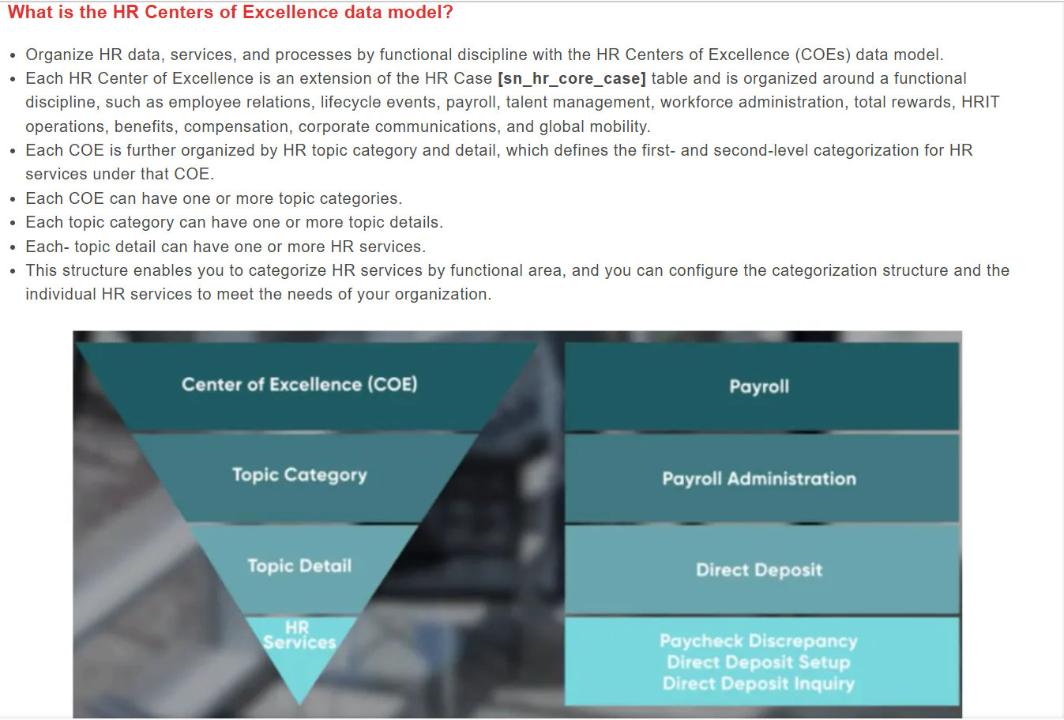
Can we disable any particular COE in HRSD?
- Yes, however, The COEs available to you may differ depending on the HR package you have.
- When you disable a COE, the corresponding HR services associated with that COE are also disable.
  - The extended tables associated with each COE are not disabled. You can still access these tables. Any active cases under a deactivated COE remain active.
  - Only the COE deactivates.
What is the HR topic category?
- Create or modify an HR topic category to define the first level of categorization for HR services.
- Each topic category is associated with a single HR Center of Excellence (COE).
- Navigate to All > HR Administration > HR Services > Topic Categories.
What are HR topic details?
- Create or modify an HR topic detail to define the second level of categorization for HR services.
- Each topic detail is associated with a single topic category and HR Center of Excellence (COE).
- Navigate to All > HR Administration > HR Services > Topic Details

What is HR Case?
An HR Case in ServiceNow is a record used to track and manage employee HR requests or issues.

• What does HRSD stand for in ServiceNow?
→ HRSD stands for Human Resources Service Delivery.
• What is the purpose of the HRSD application in ServiceNow?
→ It helps HR teams manage employee services like onboarding, benefits, and requests through cases, workflows, and portals.
• What is a COE in HRSD?
• What is the table name for HR Cases?
→ The table is sn_hr_core_case.
• What is an HR Task and how is it related to an HR Case?
→ An HR Task is a sub-task created under an HR Case to break down work. Example: Case = "Onboarding", Task = "Create email account".
• What is the use of the Lifecycle Event in HRSD?
→ It automates multiple HR tasks for events like onboarding or offboarding (e.g., assign tasks, send emails, update records).
- How do you create a new HR Service?
→ Go to HR Administration → HR Services → New, then define the COE, topic, template, case creation details, and related configuration.
- What are the components of an HR Service?
→
  - COE (Center of Excellence)
  - HR Template
  - Record Producer
  - Assigned group/user
  - HR Case options
  - Service Portal visibility rules
  - Checklist or tasks (optional)
- What is an HR Template in ServiceNow?
→ It’s a predefined set of values (like short description, priority, assigned to) that is auto-filled when an HR Case is created.
- What is an HR Record Producer?
→ It’s a form shown on the HR Portal that lets employees submit a request. It creates an HR Case in the backend.
- How do Record Producers help in HRSD?
→ They make it easy for employees to submit requests through the portal without needing to understand internal case forms.
- What is the difference between a Record Producer and a Catalog Item?
→
  - Record Producer: Creates records like HR Cases (for HRSD).
  - Catalog Item: Typically used in ITSM for service requests like “Request Laptop”.
- What are HR Case Options used for?
→ They define what actions can be taken on an HR Case (e.g., reassign, escalate, cancel, add tasks) and control UI behavior.
- How do you create an HR Case using a Record Producer?
→ A user fills the Record Producer form on the portal → Submission triggers a script or Flow → A case is created in the sn_hr_core_case table.
- Can HR Cases be created automatically? If yes, how?
→ Yes. HR Cases can be auto-created via:
- Lifecycle Events (e.g., Onboarding triggers multiple cases)
- Flows or Subflows
- Inbound email actions
- Integration or API calls

- What is the HR Knowledge Base?
→ It's a collection of HR articles that provide employees with self-help information, like FAQs, policies, and procedures.
- How do you restrict access to HR Knowledge articles?
→ Access is controlled using User Criteria, which defines who can view (canRead) or edit (canContribute) specific articles.
- What is User Criteria and how is it used?
→ User Criteria are rules that define which users can access specific content (e.g., knowledge articles, catalog items) based on roles, department, location, or group.
- What is the default Service Portal for HRSD?
→ The default portal is Employee Service Center (URL: /esc).
- What is Employee Center and how is it different from the standard portal?
→
  - Employee Center is a modern, unified portal introduced to replace older portals
  - It combines HR, IT, Facilities, and other services in one place.
  - It has better UI, search, and personalization features compared to the standard HR portal.

- What are the out-of-the-box HR roles in ServiceNow?
→ Some key roles include:
  - sn_hr_core.admin (HR Admin with full rights)
  - sn_hr_core.basic (Basic HR agent with limited access)
  - sn_hr_core.user (Employee role for case creation)
  - sn_hr_core.manager (Manager-level access)
- What is the difference between sn_hr_core.admin and sn_hr_core.basic?
→
  - sn_hr_core.admin: Full HR module access, can configure, create, edit all cases, templates, etc.
  - sn_hr_core.basic: Limited access, mostly to view and work on assigned HR cases only.
- How do you ensure HR case confidentiality?
→ By using Contextual Security which restricts access to HR Cases based on the user’s role, COE, and data they are allowed to see.
- What is contextual security in HRSD?
→ It’s a security model where users only see HR Cases relevant to their role, COE, or assignment ensuring privacy of employee data.
- Why is scoped application used in HRSD?
→ Scoped apps isolate HRSD data and logic from other parts of ServiceNow, improving security and maintainability.

✅ Assignment & Routing
- What are Assignment Rules in HRSD?
→ Rules that automatically assign HR Cases to the right HR group or agent based on criteria like COE, case type, or employee location.
- What are Matching Rules in HRSD?
→ Criteria-based rules to match HR Cases with the appropriate HR agent or group based on skills, expertise, or workload.
- How are HR Cases routed to the correct agent?
→ Through Matching Rules and Assignment Rules which evaluate case details and assign it to the best fit HR agent/group.
- Can you manually assign HR Cases to HR agents?
→ Yes, HR Cases can be manually reassigned by HR agents or admins if automatic routing is not suitable.
- What happens if no matching rule is found?
→ The case is assigned to a default group or fallback queue to ensure it doesn’t stay unassigned.

✅ HR Workflows & Automation
- What is the purpose of Flow Designer in HRSD?
→ It allows building automated HR workflows visually without code, such as case creation, notifications, and approvals.
- What is a subflow, and when would you use it in HRSD?
→ A subflow is a reusable mini-workflow used inside flows for common tasks like sending emails or creating cases.
- What are Case Templates and how do they improve efficiency?
→ Predefined templates with default values for cases to speed up case creation and maintain consistency.
- How are notifications configured in HRSD?
→ Using Notification records or through Flow Designer’s notification actions to alert users and agents about case updates.
- What are Activities in HR Cases?
→ Activities are tasks, notes, or communications logged within a case to track progress and interactions.

HR Reporting and Performance
- What KPIs are useful for HR Case Management?
→ Common KPIs include:
  - Case resolution time
  - Number of open cases
  - Cases by COE
  - SLA compliance percentage
  - Customer satisfaction scores
- How do you create reports and dashboards in HRSD?
→ Use the Reports module to build charts and tables from HR Case data; then group reports in Dashboards for a consolidated view.
- What is a Performance Analytics indicator in HRSD?
→ It's a metric that tracks trends over time, like average case closure time or number of escalated cases, used for performance monitoring.
- Can you measure SLA performance for HR Cases?
→ Yes, you can set up SLAs (Service Level Agreements) on HR Cases and track their compliance using reports and dashboards.
- How can surveys be sent automatically in HRSD?
→ Surveys can be sent via Flows or Notifications triggered on case closure or specific case events.

✅ HRSD Use Cases and Integration
- What are common use cases implemented with HRSD?
→
  - Employee onboarding/offboarding
  - Benefits and payroll requests
  - Leave management
  - Employee relations issues
  - Policy acknowledgment tracking
- Can HRSD be integrated with Workday?
→ Yes, through APIs, IntegrationHub, or Middleware to sync employee data and automate HR processes.
- How do you handle employee onboarding in HRSD?
→ Use Lifecycle Events to trigger tasks, assign cases, send notifications, and automate onboarding workflows.
- What is Employee Document Management in HRSD?
→ A feature to store and manage employee-related documents like contracts, certifications, and ID proofs securely.
- Can Virtual Agent be used in HRSD? If yes, how?
→ Yes, Virtual Agent can handle common HR questions and case creation by interacting with employees via chat on the portal.

